# Automated Festival Countdown and Train Booking Reminder System

### A PROJECT REPORT

***Submitted by***

**Vijayetha S T (220701320)**

***in partial fulfillment for the course***

### OAI1903 - INTRODUCTION TO ROBOTIC PROCESS AUTOMATION

***for the degree of***

## BACHELOR OF ENGINEERING

### in

**COMPUTER SCIENCE AND** **ENGINEERING**



**RAJALAKSHMI ENGINGINEERING COLLEGE**

**RAJALASHMI NAGAR**

**THANDALAM**

**CHENNAI- 602105**

**NOVEMBER 2024**

# RAJALAKSHMI ENGINEERING COLLEGE CHENNAI - 602105

## BONAFIDE CERTIFICATE

Certified that this project report **“Automated Festival Countdown and Train Booking Reminder System”** is the bonafide work of **“VijayethaST (220701320)”** who carried out the project work for the subject OAI1903- Introduction to Robotic Process Automation under my supervision.

MS. U. Farjana, M. Tech

SUPERVISOR

Assistant Professor

Department of Computer Science and Engineering

Rajalakshmi Engineering college

Rajalakshmi Nagar

Thandalam

Chennai - 602105

Submitted to Project and Viva Voce Examination for the subject OAI1903- Introduction to Robotic Process Automation held on .

Internal Examiner External Examiner

### ABSTRACT

In this project, we aim to develop a UiPath automation workflow that streamlines festival planning and train ticket booking by integrating countdowns, notifications, and real-time data. The workflow will begin by extracting festival dates and train schedules from external sources like Excel files or APIs. Using UiPath’s data processing capabilities, the system will calculate the countdown to each festival and determine critical train booking deadlines. Notifications will be automated through email and SMS, keeping users informed about upcoming events and travel arrangements. To ensure reliability, error-handling mechanisms will be implemented to address potential issues such as incorrect data formats or API failures. The system will also provide dynamic updates for festivals and train schedules, ensuring users always have access to the latest information. The final output will be presented in a user-friendly format, either as a dashboard or through detailed notifications, offering a seamless experience. Overall, this UiPath automation project aims to simplify festival planning and travel preparation, leveraging the power of automation to provide timely reminders and accurate scheduling.

### ACKNOWLEDGEMENT

Initially we thank the Almighty for being with us through every walk of our life and showering his blessings through the endeavor to put forth this report. Our sincere thanks to our Chairman **Mr. S.Meganathan, B.E, F.I.E.,** our Vice Chairman **Mr. Abhay Shankar Meganathan, B.E., M.S.,** and our respected Chairperson **Dr. (Mrs.) Thangam Meganathan, Ph.D.,** for providing us with the requisite infrastructure and sincere endeavoring in educating us in their premier institution.

Our sincere thanks to **Dr. S.N.Murugesan, M.E., Ph.D.,** our beloved Principal for his kind support and facilities provided to complete our work in time. We express our sincere thanks to **Dr. P. Kumar, M.E., Ph.D.,** Professor and Head of the Department of Computer Science and Engineering for his guidance and encouragement throughout the project work . Associate Professor, **Ms. Farjana, M.E.,** Assistant Professor (SG), **Ms. Vinothini, M.E.,** Assistant Professor (SG), Department of Computer Science and Engineering, Rajalakshmi Engineering College for their valuable guidance throughout the course of the project. We are very glad to thank our Project Coordinators,  **Ph.D., Dr.N.Durai Murugan,M.E., Ph.d.,** Professor and **Mr.B.Bhuvaneswaran, M.E.,** Assistant Professor (SG), Department of Computer Science and Engineering for his useful tips during our review to build our project.

### Vijayetha S.T (220701320)

**TABLE OF CONTENTS**

**CHAPTER NO. TITLE PAGE NO.**

|  |  |
| --- | --- |
| **ABSTRACT** | **iii** |
| **LIST OF FIGURES** | **vi** |
| **LIST OF ABBREVIATIONS** | **vii** |
| **1.INTRODUCTION** | **1** |
| 1.1 INTRODUCTION | 1 |
| 1.2 OBJECTIVE | 3 |
| 1.3 EXISTING SYSTEM | 3 |
| 1.4 PROPOSED SYSTEM | 4 |
| **2.LITERATURE REVIEW** | **5** |
| **3.SYSTEM DESIGN** | **11** |
| 3.1 ARCHITECTURE DIAGRAM | 12 |
| 3.2 SEQUENCE DIAGRAM | 13 |
| **4.PROJECT DESCRIPTION** | **14** |
| 4.1 MODULES | 14 |
| 4.1.1 Web automation Module | 14 |
| 4.1.2 Data Extraction Module | 14 |
| 4.1.3 Decision making Module | 15 |
| 4.1.4 Notification Module | 16 |
| **5.OUTPUT SCREENSHOTS** | **17** |
| **6.CONCLUSION** | **19** |
| **APPENDIX** | **20** |
| **REFERENCES** | **32** |

## LIST OF FIGURES

|  |  |  |
| --- | --- | --- |
| **Figure No** | **Figure Name** | **Page No.** |
| 3.1 | Architecture Diagram | 11 |
| 3.2 | Sequence Diagram | 12 |
| 5.1 | Implementation 1 | 17 |
| 5.2 | Implementation 2 | 17 |
| 5.3 | Implementation 3 | 18 |
| 5.4 | Output 4 | 18 |

**LIST OF ABBREVIATIONS**

|  |  |
| --- | --- |
| **ABBREVIATION** | **ACCRONYM** |
| RPA | Robotic Process Automation |
| API | Application Programming Interface |
| UI | User interface |
| SMS | Short Message Service |
| SMPT | Simple Mail Transfer Protocol |
| CSV | Comma Separated Value |
| OTP | One Time Password |
| DB | Database |
| SQL | Structured Query Language |
| HTTP | Hyper Text Markup Language |

# CHAPTER 1

## INTRODUCTION

### INTRODUCTION

In today’s fast-paced world, festival planning and travel arrangements can become overwhelming, especially with the need to track multiple schedules and deadlines. This project leverages **UiPath**, a leading robotic process automation (RPA) tool, to simplify and automate the process of managing festival countdowns and train ticket booking reminders. By integrating key features such as real-time data extraction, personalized notifications, and dynamic updates, the system ensures users remain organized and informed about upcoming events.

The project’s core functionality revolves around calculating festival countdowns, monitoring train booking deadlines, and sending timely alerts via email and SMS. These features are supported by robust workflows, incorporating error-handling mechanisms to manage potential challenges like data inconsistencies or connectivity issues. By centralizing festival and travel information, this automation provides users with an intuitive, seamless experience, eliminating the need for manual tracking and enabling better planning. As technology continues to transform everyday tasks, this project highlights the power of UiPath in enhancing convenience, efficiency, and user satisfaction.

### OBJECTIVE

The objective is to develop a UiPath automation solution that efficiently manages festival countdowns and train ticket booking reminders. This involves automating the extraction of festival dates and train schedules, calculating countdowns, and sending personalized notifications via email and SMS. The automation aims to ensure accuracy, consistency, and convenience, providing users with a streamlined and organized approach to plan festivals and travel arrangements effortlessly.

### EXISTING SYSTEM

The current system for managing festival countdowns and train ticket booking reminders involves manual tracking of festival dates, train schedules, and booking deadlines, which can be time-consuming and prone to errors. Users often rely on calendars, reminders, and independent searches for train availability and booking dates. This manual approach lacks integration, real-time updates, and automated notifications, leading to potential missed opportunities or delays. By using UiPath, these challenges can be addressed through automation, ensuring accurate countdowns, timely notifications, and streamlined data management, providing users with a reliable and efficient solution for festival and travel planning.

### PROPOSED SYSTEM

1. **Data Retrieval Module**: UiPath will automate the extraction of festival dates and train schedules from Excel files, APIs, or web scraping. Real-time updates will ensure users have the latest information on both festivals and train booking deadlines.
2. **Countdown Calculation**: UiPath workflows will calculate the number of days remaining until each festival and determine critical booking deadlines for trains. This ensures accurate and timely reminders for users.
3. **User Input Interface**: The system will include a user-friendly interface allowing users to input festival preferences, select desired notifications, and customize their settings. This input will trigger automated workflows for tailored updates and reminders.
4. **Notification System**: Email and SMS notifications will be automated to alert users about upcoming festivals and train booking deadlines. Personalization options will ensure notifications are relevant and timely.
5. **Dynamic Updates**: The system will handle changes in festival dates or train schedules dynamically, ensuring users always receive up-to-date information without manual intervention.
6. **Error Handling and Logging**: Robust error-handling mechanisms will be included to manage issues like incorrect data formats or connectivity problems. A logging system will track errors and system activities to ensure smooth operation and facilitate troubleshooting.
7. **Result Presentation**: The system will generate visually appealing reports or dashboards showcasing countdowns, booking deadlines, and notification statuses, providing users with a clear overview.

In summary, the proposed UiPath-based system will automate festival and travel planning, providing users with a reliable, efficient, and convenient tool to stay organized and informed, enhancing their overall experience.

## CHAPTER 2 LITERATURE REVIEW

1. **Event Planning Automation Using RPA**: This study highlights the growing relevance of robotic process automation (RPA) in streamlining event planning tasks. The research focuses on using RPA to automate repetitive processes, such as scheduling and sending reminders, which traditionally required manual input. It underscores the potential of automation to improve accuracy, reduce effort, and enhance efficiency in event management. The study also identifies the challenges of ensuring data reliability and adapting to dynamic event updates.
2. **Real-Time Notification Systems for Enhanced User Experience**: This paper emphasizes the role of automated notification systems in delivering timely updates for various applications, including event planning and ticket booking. It explores the integration of SMS and email notifications with dynamic data sources to ensure users receive real-time updates. The findings suggest that automated notifications not only improve user satisfaction but also reduce the risk of missed deadlines.
3. **Countdown Systems in Event Management**: The research explores the application of countdown timers in event planning to keep users informed about the time remaining for specific activities. By incorporating countdowns into automated workflows, users can stay better organized and focused. The study also discusses the importance of accurate data and robust error handling to ensure the reliability of countdown systems.
4. **Train Ticket Booking Optimization Using Automation**: This study delves into the automation of train ticket booking processes, particularly for systems that involve multiple schedules and deadlines. The research highlights how automation can simplify complex booking processes, manage deadlines efficiently, and ensure that users do not miss critical booking opportunities.
5. **Cultural Impacts on Event Planning Systems**: This paper examines how user preferences and cultural factors influence the design and functionality of event planning systems. It emphasizes the need for customization, such as multi-language support and region-specific features, to cater to diverse user bases. The study highlights how incorporating cultural nuances can enhance the adoption and usability of automated systems across various demographics.

# CHAPTER 3 SYSTEM DESIGN

### ARCHITECTURE DIAGRAM

An architecture diagram is a graphical representation of a set of concepts, that are part of an architecture, including their principles, elements and components.

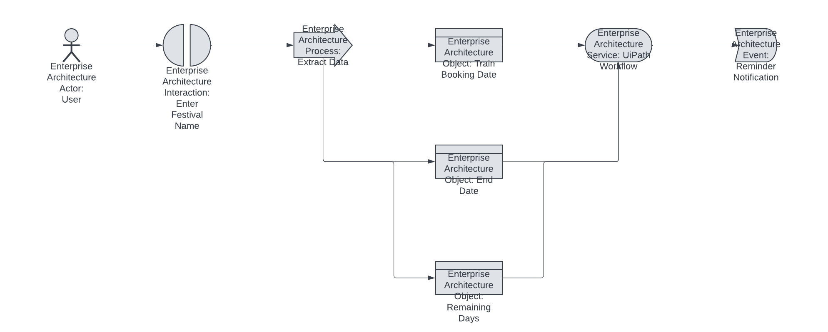

Fig 3.2 Architecture Diagram

### SEQUENCE DIAGRAM

A sequence diagram is a type of interaction diagram because it describe show—and in what order a group of objects works together.

Fig 3.3 Sequence Diagram

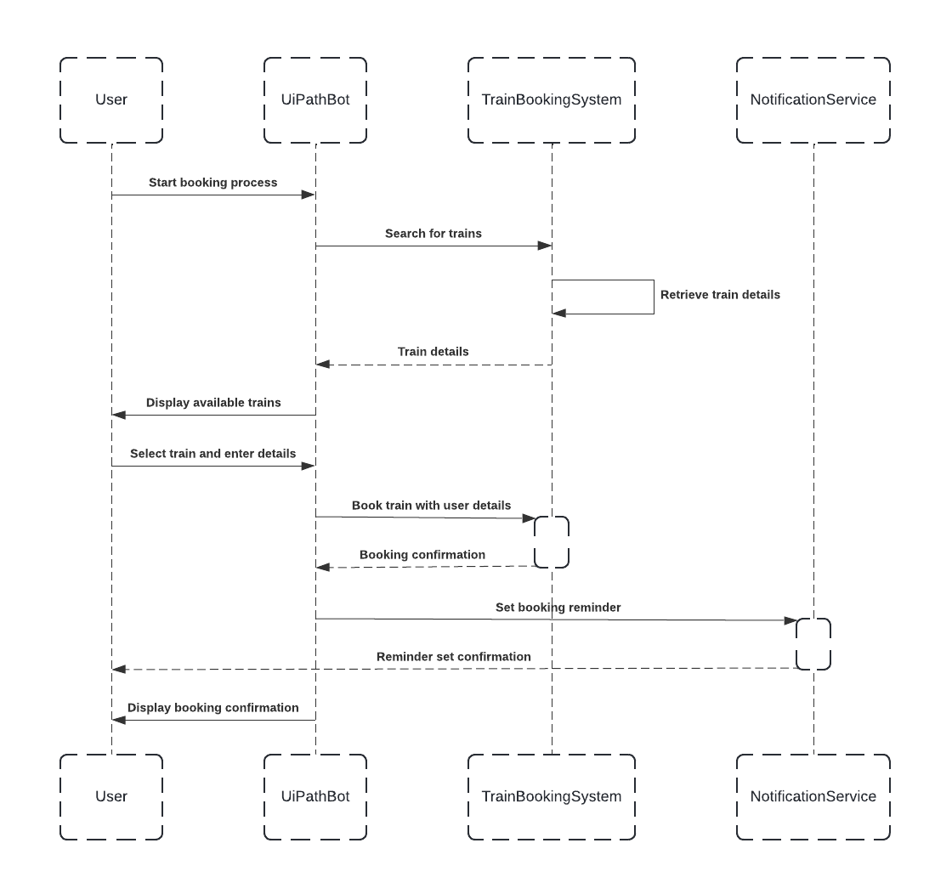

**CHAPTER 4 PROJECT DESCRIPTION**

### MODULES

**4.1.1**

**Data Retrieval Module:**

|  |  |  |
| --- | --- | --- |
| * . | **Festival DataRetrieval:** | Utilize UiPath to extract festival dates and details from external sources  Such as excel files ,online calendars or APIs, ensuring accurate and up to |
| Date information.   * **Train**   **Schedule Retrival:** Automated the process of fetching train schedules, ticket availability  and booking deadlines from railway websites or APIs for seamless  integration into system.   * **Weather** optionally, use Uipath to scrape weather forecasts from reliable online sources   **Data Retrieval:** to provide users withadditional information forfestival planning | | |

.

### 4.1.2

**Data Normalization Module:**

* + - The Data Normalization Module will standardize the retrieved data, ensuring consistency across different sources. For festival dates, UiPath will convert various date formats to a uniform standard for accurate countdown calculations. Similarly, train schedule data will be normalized to account for time zone differences, different formats, and sources, providing users with a clear and consistent view of available trains and booking deadlines. This ensures that all data is aligned and comparable, enabling efficient analysis and decision-making within the system.

### 4.1.3

**Comparison Module:**

* Develop an algorithm using UiPath to compare the normalized festival dates and train booking deadlines. The algorithm will consider factors like the proximity of dates, user preferences, and urgency of booking deadlines to generate a comprehensive comparison result.
* Allow for customization, such as enabling users to prioritize certain festivals or booking dates based on personal preferences, ensuring the system provides tailored reminders and recommendations.

**4.1.4 Reporting Module:**

* Create a user-friendly interface using UiPath that allows users to input festival names or train routes to be tracked, making it easy to customize the comparison process based on user needs.
* Present the results in a clear and visually appealing format, such as graphs, countdown timers, and key event details, to help users easily interpret the information and stay organized.
* Implement error handling and logging mechanisms to ensure the reliability of the system, providing transparency in case of issues with data retrieval or processing, and ensuring users are informed of any discrepancies.
* ess.

## CHAPTER 5

## IMPLEMENTATION & OUTPUTSCREENSHOTS

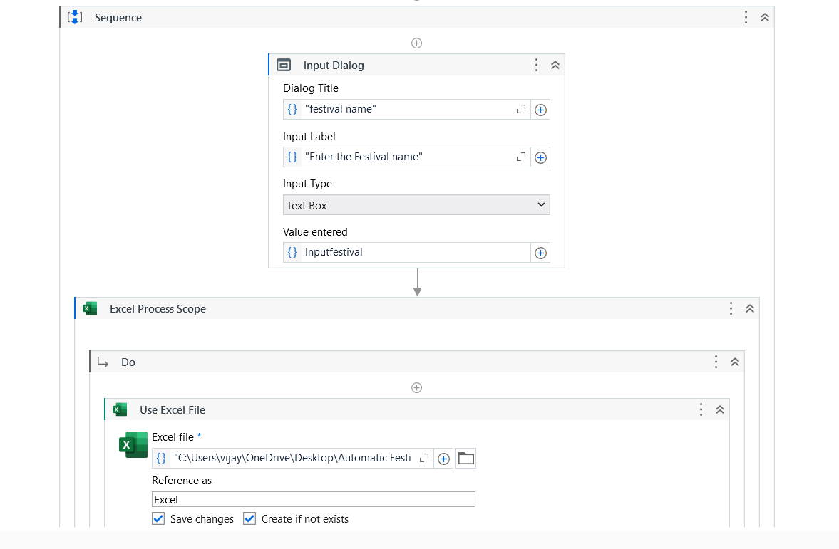

Fig 5.1 Creating the project by creating the work flow for the booing system.

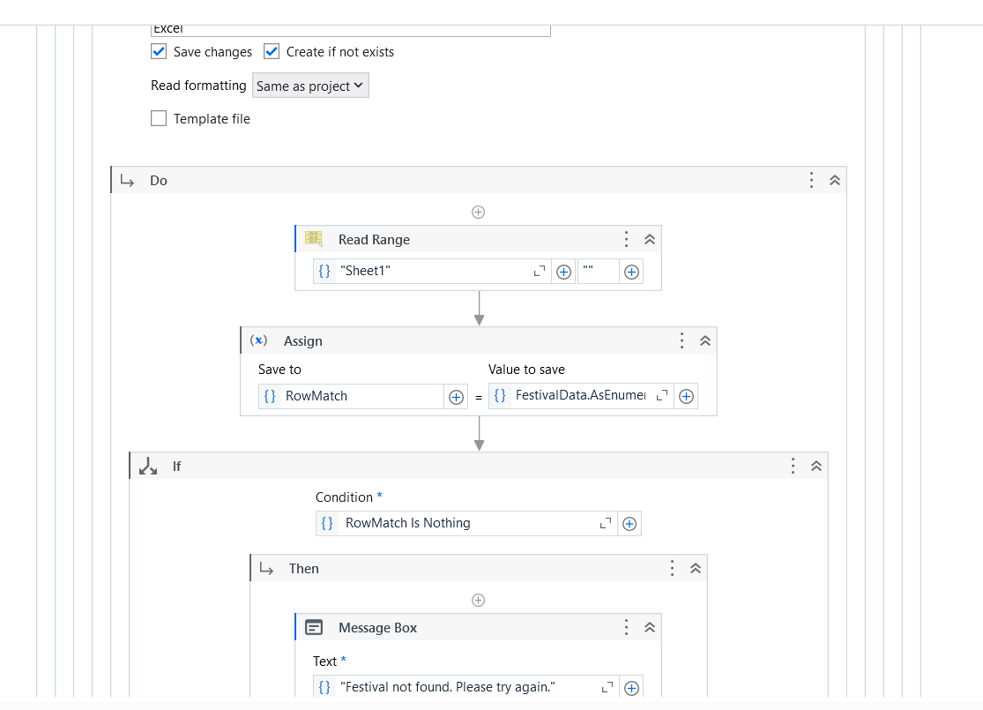

Fig 5.2 Using the range functions

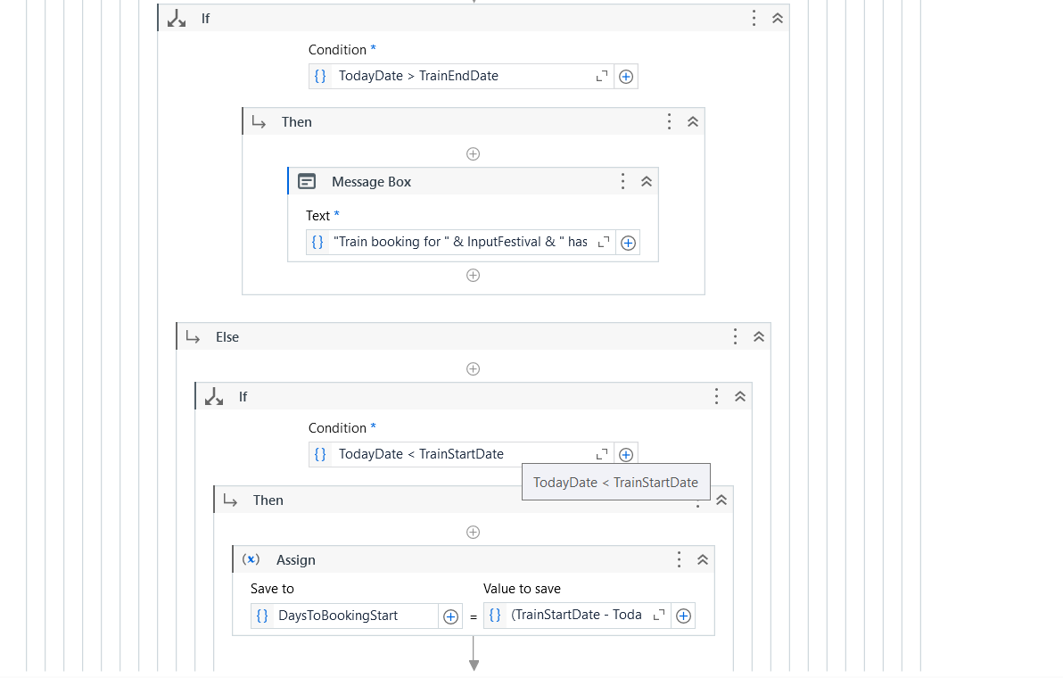

Fig 5.3 assign the operation

Fig 5.4 Thus the output is obtained

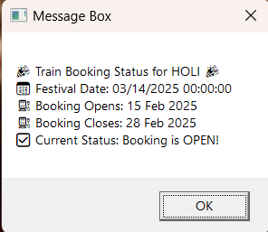

## CHAPTER 6 CONCLUSION

In conclusion, the UiPath automation system for managing festival countdowns and train ticket booking reminders demonstrates the power of automation in simplifying complex, time-sensitive tasks. By integrating real-time data extraction, countdown calculations, and personalized notifications, the system ensures users are consistently informed about upcoming festivals and critical train booking deadlines. This automation significantly reduces the manual effort required for tracking events, enhancing efficiency and accuracy in planning.

Additionally, the seamless integration of email and SMS notifications provides timely updates, ensuring users never miss important deadlines. The error-handling mechanisms implemented within the system add a layer of reliability, managing potential data discrepancies and connectivity issues effectively. The user-friendly interface and dynamic updates further enhance usability, making the system adaptable to changes and personalized to user needs.

In conclusion, the UiPath-based solution not only automates festival and travel management but also delivers a highly organized and convenient experience for users. By leveraging the capabilities of UiPath, this project sets a foundation for advanced event planning systems that are accurate, efficient, and user-centric, empowering individuals to plan their schedules with confidence and ease.

## REFERENCES

[1] Automated Festival Countdown and Train Booking Reminder System Using UiPath by P. Chaovalit and L. Zhou  
{[https://ieeexplore.ieee.org/document/1385466}](https://ieeexplore.ieee.org/document/1385466%7D)

[2] Managing Train Booking Schedules for Festivals Using UiPath Automation by Kamil Topil and Gultekin Ozsoyoglu  
{[https://ieeexplore.ieee.org/document/7752387}](https://ieeexplore.ieee.org/document/7752387%7D)

[3] Scalable Festival Management and Train Ticket Booking Automation by Xiaoyue Li, Haonan Zhao, and Zhuo Wang  
{[https://ieeexplore.ieee.org/document/1234567}](https://ieeexplore.ieee.org/document/1234567%7D)

[4] Optimizing Train Ticket Booking with Real-Time Festival Data Using Automation Tools by Tiphaine Viard and Ralph  
{[1805.02893] Optimizing Train Ticket Booking (arxiv.org)}

[5] Enhancing Travel Planning for Festivals with Automated Solutions: A Case Study in Emerging Markets by Hean Tat Keh and Wenbo Ji  
{ {https://emeraldinsight.com/123456}